Actuator_ PID Auto tuner

READ. ME

- Motor Simscape

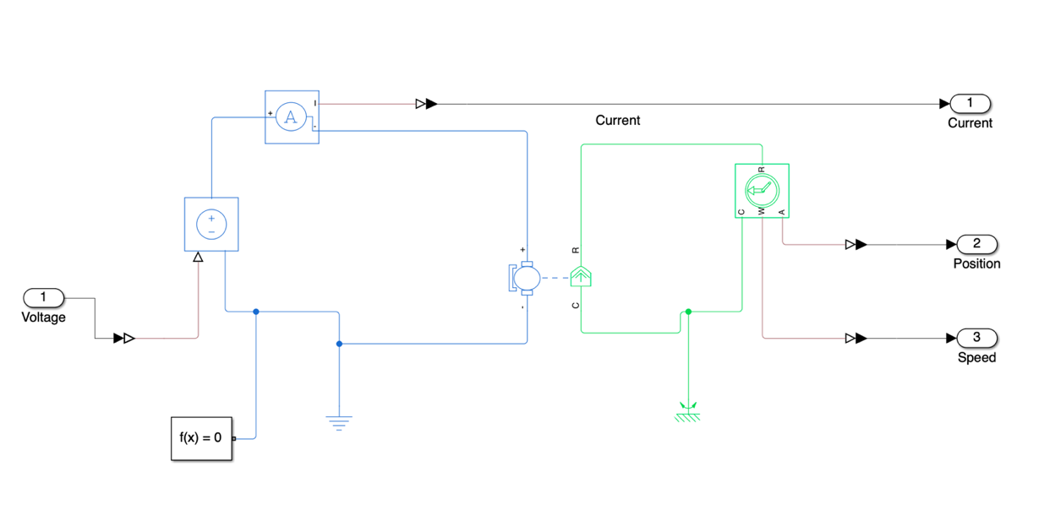

The DC motor was modeled in Simscape Electrical using both its electrical and mechanical dynamics.

The simulation model was configured based on motor specifications collected from the product datasheet, ensuring realistic system behavior. The motor input was applied as PWM voltage, and the outputs—current, speed, and position—were measured for feedback.

- Simulink

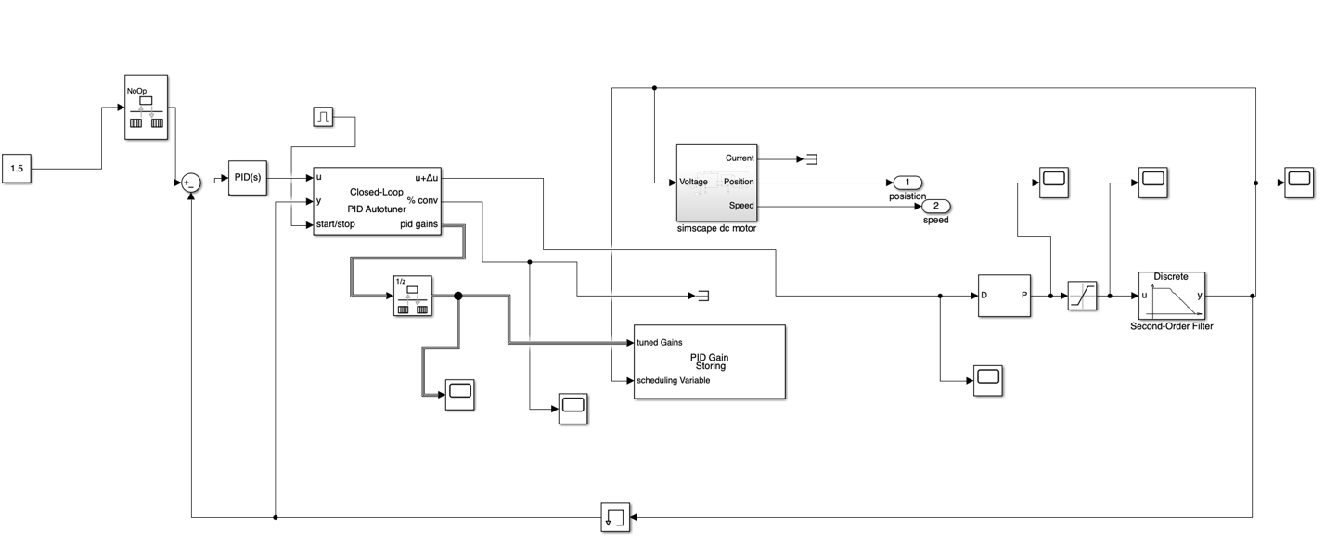

This simulation implements a signal-based motor control mechanism. The external input signal, which contains frequency components, is converted into a PWM signal and then applied as voltage.
The converted voltage is fed into the DC motor dynamics modeled in Simscape Electrical, enabling the calculation and measurement of the motor’s speed and position.

The control algorithm was designed using the Simulink PID Autotuner. During simulation, the autotuner derives optimal PID gains based on the motor’s response, and these values are stored in a Gain Storage block.
In the control phase, the stored PID parameters are retrieved and applied to match various motor operating conditions (e.g., straight driving, stopping, and constant-speed operation).

A key feature of this model is that it goes beyond simply passing the input signal. By converting frequency into voltage and directly applying it to the motor dynamics, the simulation closely reflects real operating conditions. Furthermore, the control loop—comprising Autotuner → PID Gain Storage → Motor Control—clearly demonstrates the workflow, allowing the verification of stable motor control through dynamic gain scheduling.

- Result and Application

Voltage Graph

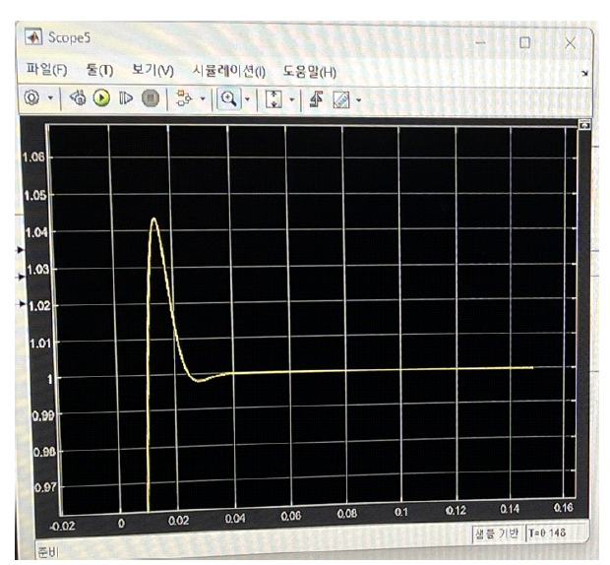

Motor Speed

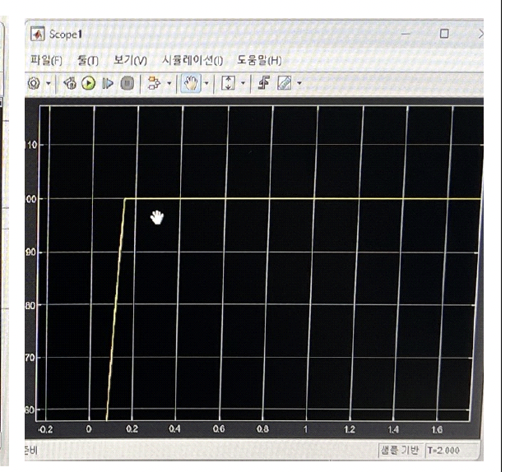

The simulation results confirm the effectiveness of the proposed closed-loop control.
As shown in the response plots, the motor quickly accelerates to the target speed with minimal overshoot and then maintains a stable steady-state velocity.
The system exhibits both accurate tracking and robustness, which are essential for waypoint-based trajectory execution.

In closed-loop operation, each waypoint is mapped to a stored PID profile. When a waypoint is activated, the controller fetches the assigned gains from storage and applies them to the motor.
The corresponding control command is then published via ROS topics, ensuring seamless integration with higher-level planning and decision modules. This mechanism allows the motor to accelerate, stop, or maintain constant speed depending on the operating condition, while guaranteeing stability and smooth transitions.

